1. What is the name of the oldest movie in the database that has a top rating?

Name Year Rating

Song of Freedom 1936 5.0

1. Word Length Count 1.

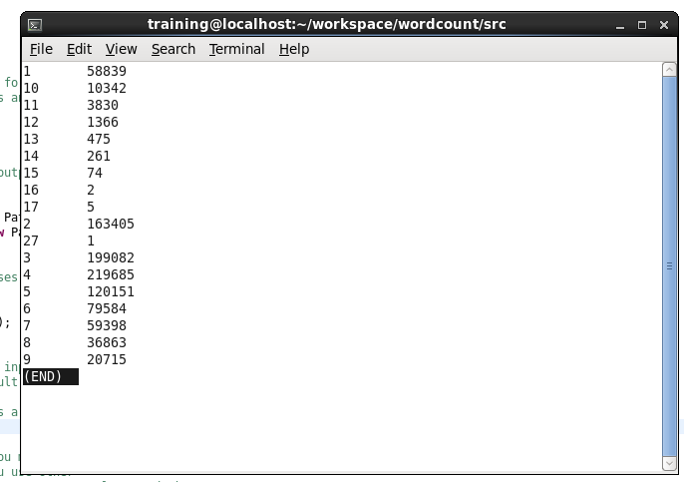

1. Word Length Count 2.

